Testes do Projeto

kubectl get pods -A | grep f

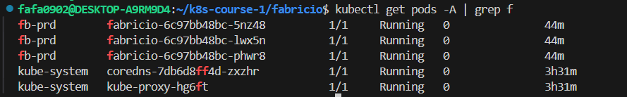

Kubectl Describe configmap

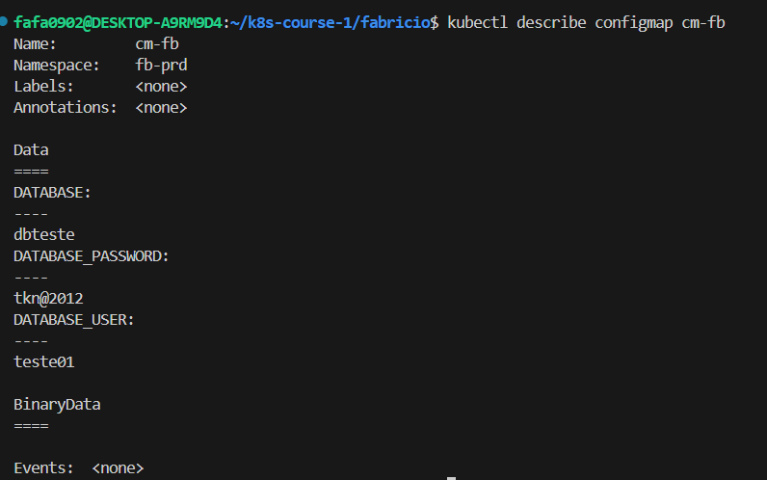

Kubectl Get services

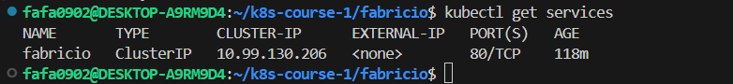

Kubectl get nodes

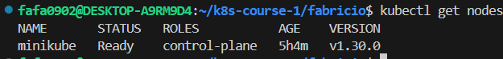

Kubectl describe service

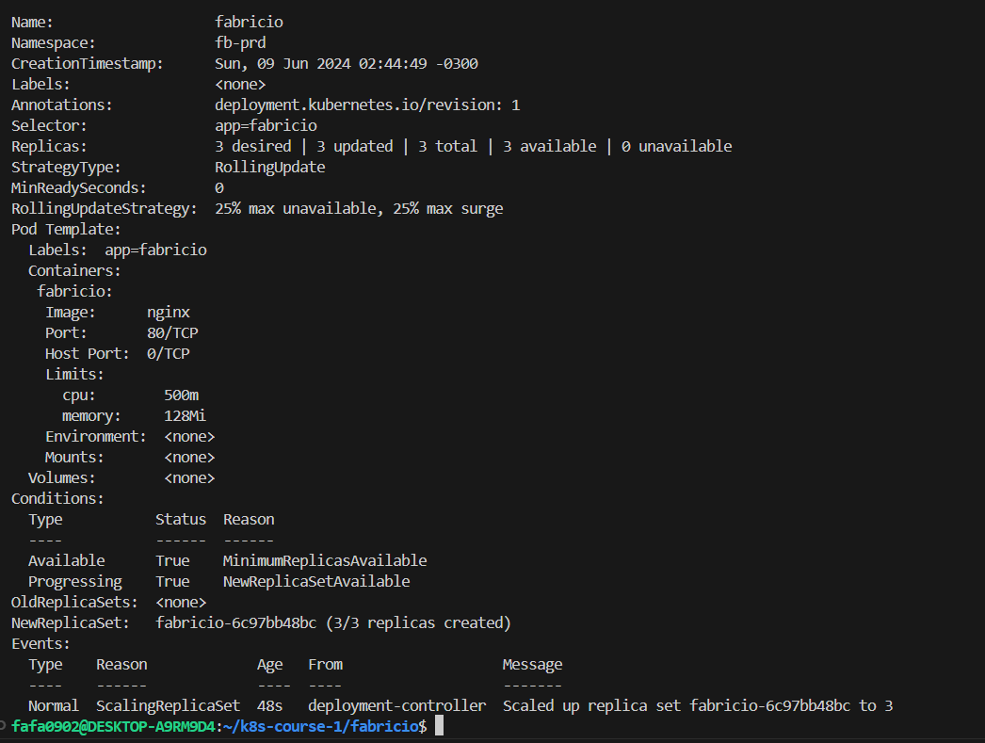

kubectl get pods -n fb-prd -o wide

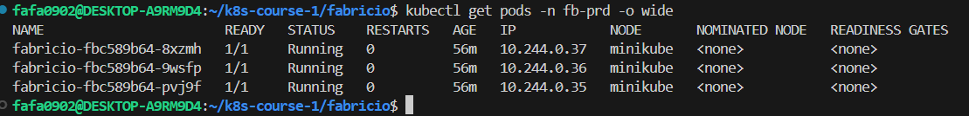

kubectl get secret

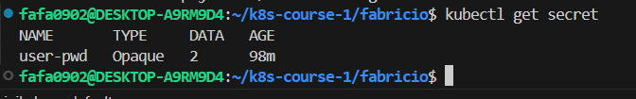

kubectl describe cm cm-fb

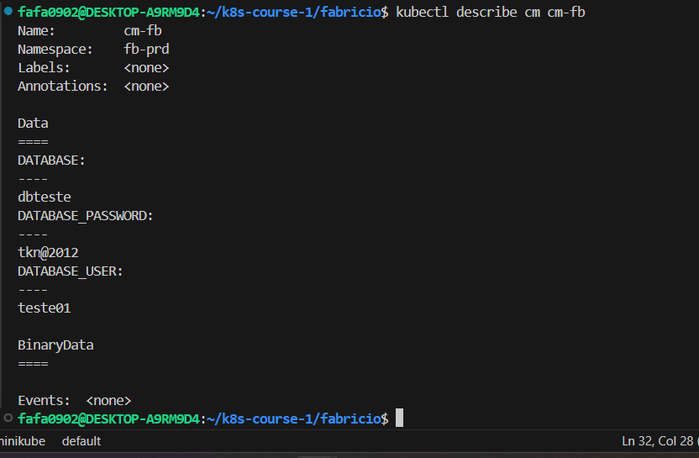

kubectl describe secret

